Web Designing Assignment

Module (HTML – 5)

**(1) what are the new tage added HTML-5?**

ANS: The following tage (element) have brrn introduced in HTML-5

<article>

<section>

<header>

<footer>

<nav>

<svg>

<embed>

<mark>

<output>

<audio>

<video>

<details>

<command>

<figure>

<canvas>

<progress>

**(2) How to embed audio and video in a webpage?**

ANS:

1. Add an HTML5 media player to your webpage using the <audio>or<video>
2. Specify the source of your media file using the src attribute
3. Add any additional attribute , such as control , to customize the player,s behaviour.

Audio:Here’s an example of how to embed an MP3 file using the <audio> tag

Video: Here’s an example of how to embed an MP4 file using the <video> tag

Input:

<!DOCTYPE html>

<html lang="en">

<head>

    <meta charset="UTF-8">

    <meta http-equiv="X-UA-Compatible" content="IE=edge">

    <meta name="viewport" content="width=device-width, initial-scale=1.0">

    <title>Document</title>

</head>

<body>

    <!-- audio tag start -->

        <audio src="futuristic-beat-146661.mp3" controls></audio>

         <!-- audio tag End -->

         <!-- video tag start -->

        <video src="pexels-宇航-钱-10641431-2160x3840-25fps.mp4" controls loops width="400px" height="400px"></video>

          <!-- video tag End -->

</body>

</html>

Output:

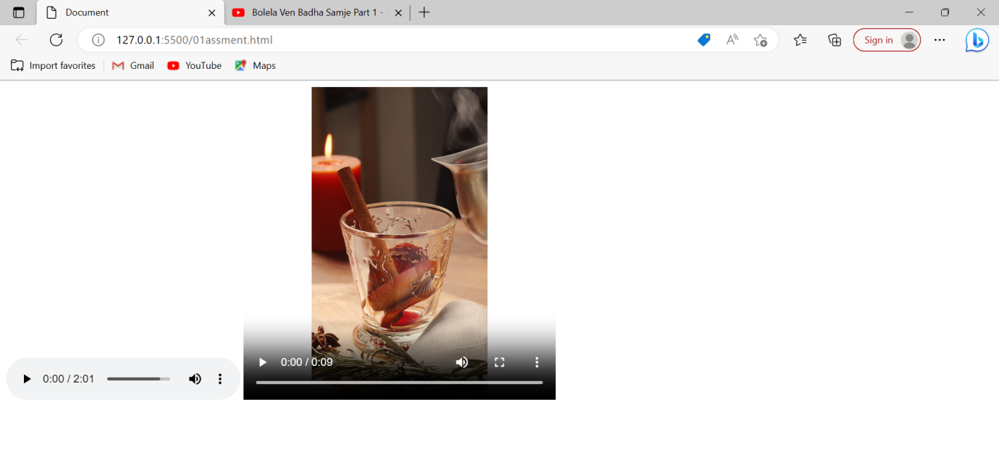

**(3) semantic eiement in HTML5?**

ANS:

Semantic eiement are HTML5 eiemente thet have a specific meaning and pupose beyond their purely visial appearance. They help to structure a webpage’s content and provide additional information about the page’s content to search engines , and other web technologies.

Some examples of HTML semantic elements inciude:

<header>: Defines a header section for a webpage or a section within a webpage.

<nave>:Defines a navigation section that contains links to other pages or sections within the same page.

<main>:Defines the main content of a webpage.

<section>:Defines a section of content within a webpage.

<article>:Defines an independent piece of content, such as a blog post or news article.

<aside>:Defines content yhat is related to the main content but not necessarily part of it, such as a sidebar or call-out box.

<footer>:Defines a footer section for a webpage or a section within a webpage . using semantic element in your HTML code can make your webpage more accessible and easier to understand for both users and machines.

They can also help with search engine optimization (SEO) by providing additional context to search engines about your webpage’s content.

**(4) Canvas and SVG tags.?**

ANS:

Canvas: The HTML5 canvas element can be used to draw graphics on the webpage via javascript

By default the <canvas> element has 300px of width and 150px of height without any border and content. However,custom width and height can be defined using the CSS height and width property whereas the border can be applied using the CSS border property.

Example:

Input:

<!DOCTYPE html>

<html lang="en">

<head>

    <meta charset="UTF-8">

    <meta http-equiv="X-UA-Compatible" content="IE=edge">

    <meta name="viewport" content="width=device-width, initial-scale=1.0">

    <title>Document</title>

</head>

<body>

        <!-- canvas tag start -->

        <canvas id="one" height="100" width="400" style="border: 2px solid blue;"></canvas>

        <!-- canvas tag End -->

        <!-- script tag start -->

        <script>

            var c= document.getElementById("one");

            var ctx = c.getContext("2d");

            ctx.font = "30px Arial";

            ctx.fillText ("welcome to the my webpage",10,50)

        </script>

        <!-- script tag End -->

</body>

</html>

Output:

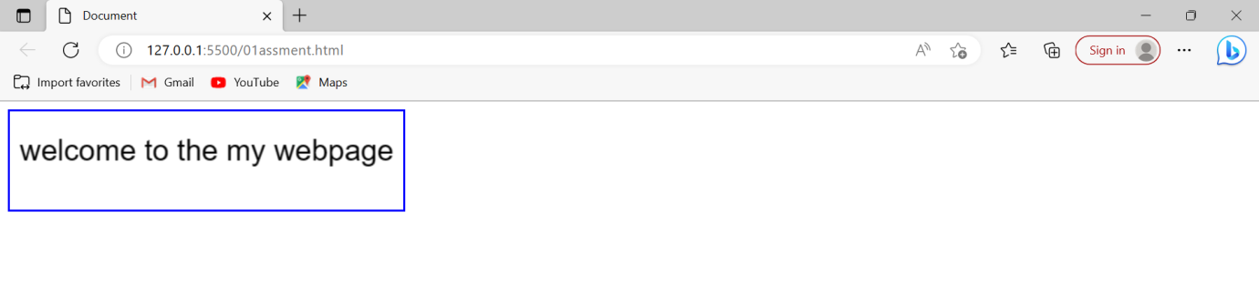

SVG: The scalable vector Graphics (SVG) is an XML – based image format that is used to define two-dimensional vector based graphics for the web.

Unlike raster image (e.g, .jpg, .gif, .png, etc), a vector image can be scaled up or down to any extent without losing the image quality.

Example:

Input:

<!DOCTYPE html>

<html lang="en">

<head>

    <meta charset="UTF-8">

    <meta http-equiv="X-UA-Compatible" content="IE=edge">

    <meta name="viewport" content="width=device-width, initial-scale=1.0">

    <title>Document</title>

</head>

<body>

    <svg>

        <circle cx="100" cy="100" r="45" stroke="red" stroke-width="10" fill="green"></circle>

    </svg>

</body>

</html>

Output:

